
FULL RELEASE

Contact Information:
Michael Wright
Director of Marketing
New Way Air Bearings
50 McDonald Blvd., Aston, PA 19014 USA
Phone 610.364.3453 Email mwright@newwayairbearings.com

FOR IMMEDIATE RELEASE
New Way Announces Air Bearings 101 Webcast.

New Way® Air Bearings to Host Webcast for Mechanical Engineering Students
Covering the Fundamentals of Frictionless Motion on Tuesday, September 27, 2011.

Aston, Pennsylvania, USA – September 21, 2011 - New Way® Air Bearings, the world's largest independent manufacturer of porous media air bearing products, announced that it will host ‘Air Bearings 101’ – a webcast for collegiate mechanical engineering students – on Tuesday, Sept. 27, 2011, at 1:00 pm EDT. See http://bitly.com/AirBearings101Webcast for registration information.
The webcast will cover air bearings and the fundamentals of frictionless motion, and was created specifically for an academic audience, including undergraduates, graduate students, and doctoral candidates. Content is appropriate for anyone new to air bearing components, and the benefits they offer for precision engineering applications. The Air Bearings 101 webcast also makes an excellent refresher course for professors and lecturers in mechanical engineering.
The presentation will be hosted by Drew Devitt, founder, chairman, and CTO of New Way Air Bearings. Besides his experience with New Way, which he founded in 1994, Devitt’s credentials include numerous patents and articles on subjects surrounding the application of frictionless motion. He has also served as president of the American Society for Precision Engineering (ASPE). He is the ideal speaker for such a webcast because, arguably, he knows more about porous media air bearings than anyone else in the world.
--more--
“The presentation is entirely non-commercial,” Devitt noted. “We’re simply looking to give the next generation of mechanical engineers a solid foundation in frictionless motion fundamentals. The better prepared these students are, the better off the world of precision engineering will be as they establish themselves in their careers.’
‘Air Bearings 101’ is an interactive, one-hour webcast created to provide a solid overview of the subject matter, complete with animation and video vignettes which will show exactly how these precision components can work in a broad array of applications in many kinds of environments.
Specifically, the webcast will cover:
- Types of Air Bearings
- Technical Benefits Air Bearings Provide
- Load Capacity
- Compensation Methods
- Stiffness and Pre-Loading Methods
- Available Configurations
- And More

“We believe ‘Air Bearings 101’ will be a strong complement to the curriculum already being covered in the collegiate classroom,” said Nick Hackett, New Way president and CEO. “So much so that we’re encouraging professors to view the content in advance. They can download the base PowerPoint presentation at http://bitly.com/Professors-Review-PDF.
“The webcast itself is so much more than a PowerPoint,” Hackett continued. “We hope that students and professors alike will participate to avail themselves of all the content we’ll be covering live.”
Air Bearings 101 is designed to be interactive, with audience participation at several critical junctures in the presentation. The webcast will close with a web-based question-and-answer session. At the conclusion of the webcast, Mr. Devitt will continue the Q&A on Facebook for as long as students have questions.
--more--

About New Way Air Bearings
New Way® Air Bearings, Inc. is the world’s leading independent manufacturer of modular air bearing products and the recognized provider of porous media air bearing solutions. The company manufactures a standard line of modular, off-the-shelf components including: Transition and precision zone air bars; flat round and rectangular air bearings; vacuum preloaded air bearings; radial air bearings; air bushings; and air slides. The company achieved ISO 9001:2000 Certification for its quality management system in November, 2008; and achieved ISO 9001:2008 Certification in January, 2010.
New Way has now been included on Inc. Magazine's list of the 5,000 fastest-growing, private companies in America for 2007, 2008, and 2009. In November of 2007, The Greater Philadelphia Chamber of Commerce named New Way recipient of its Technological Excellence of the Year Award for 2008. In both 2008 and 2009, New Way was named a Deloitte Fast 50 Technology company for the Philadelphia, PA, USA Region.
Founded in 1994, New Way is located in Aston, Pennsylvania, USA, just fifteen minutes from Philadelphia International Airport. Visit New Way Air Bearings online at www.newwayairbearings.com. This web site includes specifications for the company’s full product range, design and installation guides, mounting hardware, air specifications, technical support, and a full range of accessories. You can also find New Way on YouTube, Facebook and Twitter. If you’d prefer even more direct contact, you can reach us at info@newwayairbearings.com, or follow the company’s official blog: Drew’s Views.
###
High-Resolution Photography
High-resolution photography is available for use by the press at http://www.newwayairbearings.com/Photography-Products or by contacting Michael Wright directly using the information below.

Michael Wright
Director of Marketing
New Way Air Bearings
50 McDonald Blvd., Aston, PA 19014 USA
Phone 610.364.3453 Email mwright@newwayairbearings.com

Image A

Drew Devitt – Informal Image
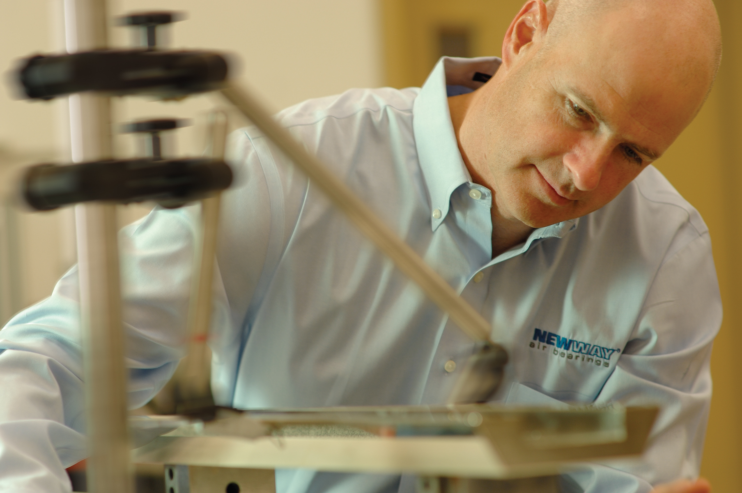

Suggested Caption:
New Way Air Bearings founder, chairman and chief technology officer Drew Devitt publishes the bi-weekly blog Drew’s Views.

Image B
Drew Devitt – Formal Image


Suggested Caption:
New Way Air Bearings founder, chairman and chief technology officer Drew Devitt will publish the bi-weekly blog Drew’s Views.

Image C
New Way Porous Media Visual
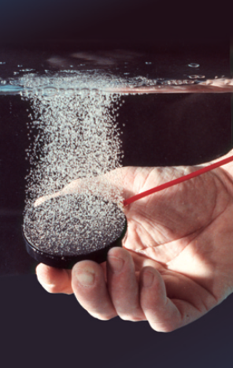

Suggested Caption:
New Way Porous Media Technology distributes air pressure uniformly across the entire bearing surface through millions of sub-micron sized holes.

Image D
New Way Flat Round Air Bearing

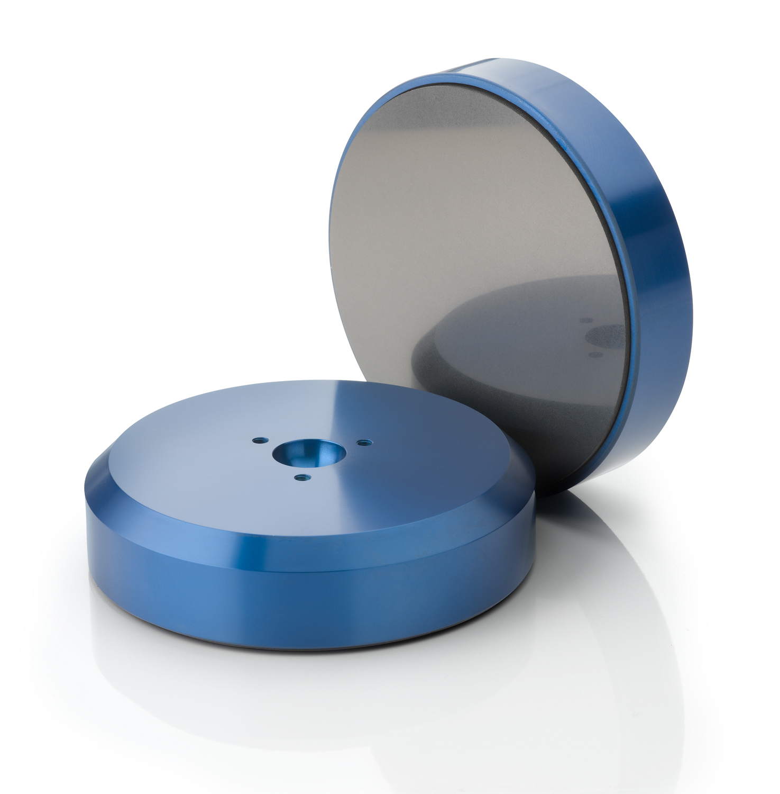

Suggested Caption:
New Way Flat Round Air Bearings are the company’s original product line, and provide for fat, easy, off-the-shelf application.

Image E
New Way Flat Rectangular Air Bearing

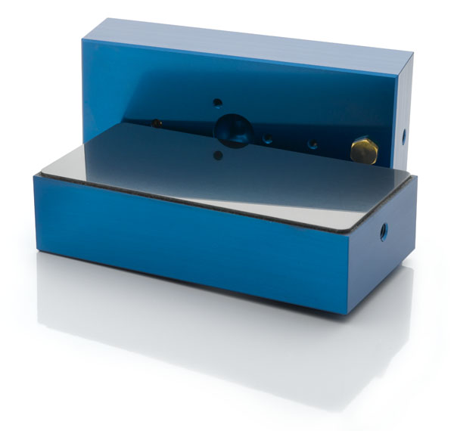

Suggested Caption:
New Way Flat Rectangular Air Bearings are an even more efficient way to apply more air bearing surface area to a given guideway width.

Image F
New Way Air Bushing

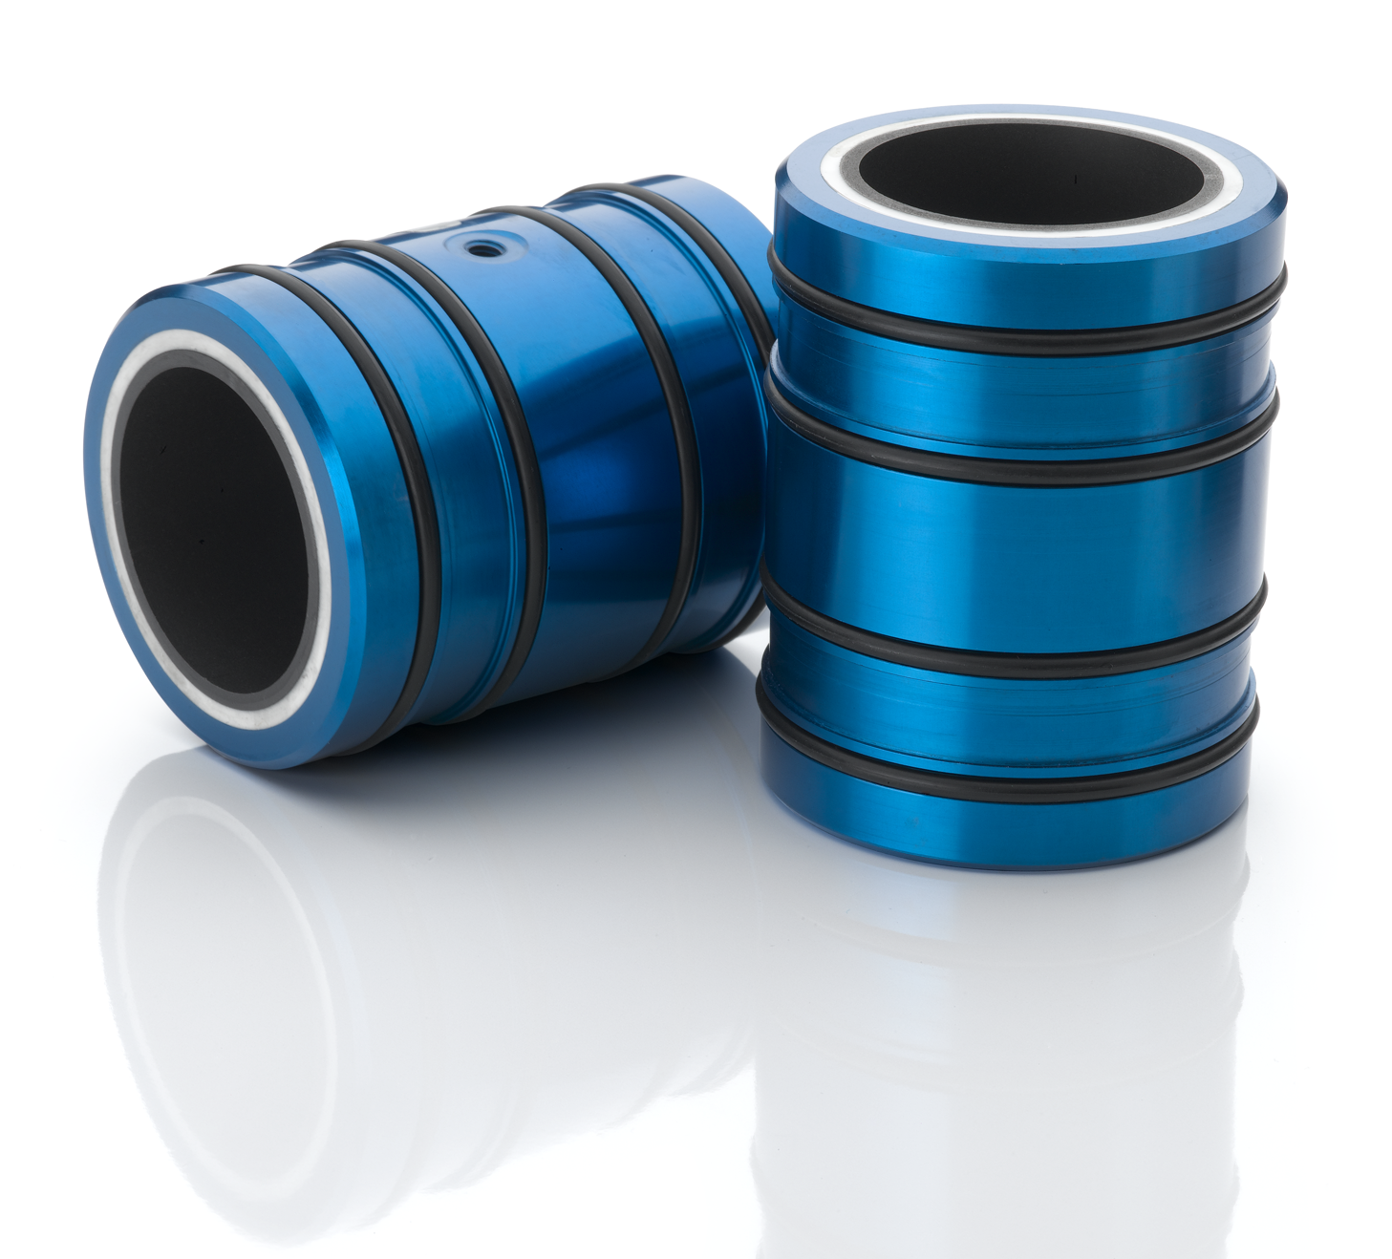

Suggested Caption:
New Way Air Bushings run on standard precision steel shafting and are available in Metric or English sizes

Image G
New Way Radial Air Bearing

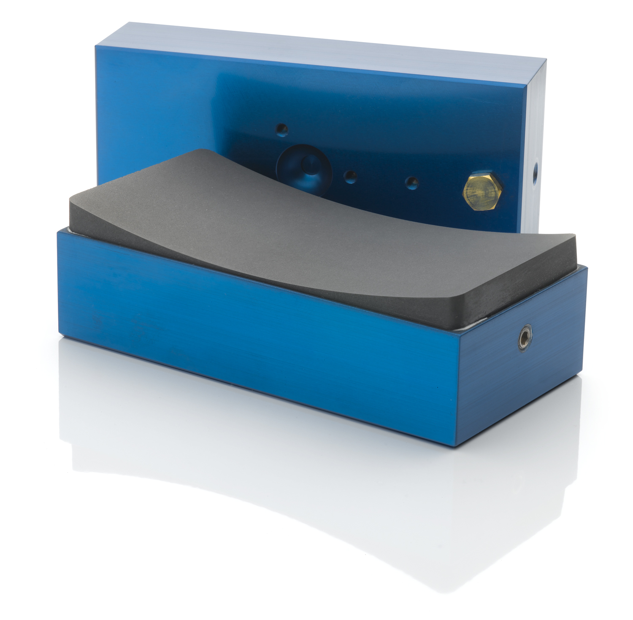

Suggested Caption:
New Way Radial Air Bearings are ideal for building frictionless rotary motion applications, and are available in either concave or convex configurations.

Image H
New Way Vacuum Preloaded Air Bearing (VPL)

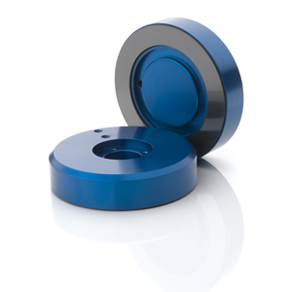

Suggested Caption:
For applications where pre-loading is difficult or impossible, Vacuum Preloaded Air Bearings add vacuum to New Way Porous Media™ Technology. Simply then, these bearings hold themselves down while simultaneously lifting themselves from the guide surface.

Logo 1
New Way Air Bearings



