
FULL RELEASE

Contact Information:
Michael Wright
Director of Marketing
New Way Air Bearings
50 McDonald Blvd., Aston, PA 19014 USA
Phone 610.364.3453 Email mwright@newwayairbearings.com

FOR IMMEDIATE RELEASE

New Way® Air Bearings Issued Patent for Air Bar Concept.

United States Patent No. 7,908,885-B2 Covers a Porous Media Air Bearing
and Glass-Flattening Device for Non-Contact Glass-Handling Applications.

Aston, Pennsylvania, USA – June 30, 2011 - New Way® Air Bearings, the world's largest independent manufacturer of porous media air bearing products, announced that it has been issued United States Patent No. 7,908,885-B2 for its ‘Non-Contact Porous Air Bearing and Glass Flattening Device.’
According to the patent, this invention is directed to a system and method for supporting thin work pieces, particularly glass, for more precise inspection, coating, patterning, and other processes without contacting the work piece.
The common technique with semiconductors was to put the substrate on a vacuum chuck. This is also how the Flat Panel Display (FPD) industry started out. But as FPD glass substrates grew larger – about Generation 6 – this technology became impractical. In the chuck method there were two primary flatness error sources: 1) The flatness of the chucks supporting the glass, including any contamination between chuck and glass, and 2) the thickness of the glass itself.

--more--
By floating the glass through a precision zone, the area that requires precision is dramatically reduced from the area of the entire vacuum chuck to the area directly under the process.
New Way Air Bearings was the pioneer in the development of non-contact glass handling components for processing and inspection, with commercial sales in Japan as early as 1999. Throughout the next decade, New Way honed its technology leadership with the release of new products enabling substrate stability to ±1 nanometer.
But the error of the thickness variation remained.
“Even high-quality Flat Panel Display (FPD) glass is subject to thickness variations, reducing processing and inspection accuracy,” noted New Way chairman and CTO Drew Devitt, who is also credited as the inventor of this New Way patent. “But this new technology stands conventional thinking on its head. It uses a combination of air pressure and vacuum from above to control and flatten the glass substrate, enabling a much higher degree of processing accuracy, all without contact.”
FPD glass has an inherent thickness variation of 5 to 7 microns; when it is sucked down to a flat vacuum chuck, all 5 to 7 microns of this variation will appear as surface-flatness error. By positioning the vacuum preloaded air bearing array on the same side as the precision process being applied to the glass, the natural thickness errors in the glass or substrate may be removed or minimized.
New Way utilizes its porous media air bearing technology to evenly distribute air pressure through millions of sub-micron sized holes across the air bar surface with the capacity to carry thousands of kilograms of load. Simultaneously, a set of vacuum holes and grooves provide tens of kilograms of atmospheric force, which evenly pushes and flattens the glass up against the air film, and holds it in a very ‘safe place.’ The result is a non-contact precision zone which presents the flattest possible glass surface to the process.
--more--
Glass thickness variation errors have started to become a limiting factor for the higher-resolution types of lithography required for higher definition displays. This new approach reduces the requirement for depth-of-field capability in the tool, and enables higher-resolution lithography, while also greatly minimizing the structural loop between the optics and the glass.
This technique also allows for:
- Viscous shear cleaning* of the surface immediately before the process,
- Isolation of process gases* or containment of particulates from ablation processes, and
- Glass conditioning* with relation to temperature, humidity, and oxygen levels in the bonding layer pre-coating.
*Which are protected by separate patents.
Today’s Generation 10 glass is 2850mm x 3050mm, or 8.7 square meters. And a structural loop which must include components above and below the glass is problematic.
“The second significant advantage of our new patent is the reduction in size of the overall structural loop,” Devitt continued. “Many contemporary FPD processing lines still feature a multi-ton granite base, a giant gantry with two large granite columns, a huge stage mechanism, and the processing equipment or inspection cameras themselves. This structural loop can be 10 meters or longer.”
“In this new embodiment, with the glass moving just 10 microns below the processing or inspection equipment, the structural loop can be just a small fraction of a meter. This avoids errors from thermal and vibration sources in the machine.” (IMAGE C)
--more--

“Of course this new technology will be particularly useful and effective in the manufacture of Flat Panel Displays,” said Nick Hackett, New Way president and CEO. “Already our Air Bars have helped to increase FPD manufacturing yields which, in turn, have helped to bring down the cost of Flat Panel TVs and Computer Monitors industry-wide. This new patented technology will enable the even more highly-precise processing and inspection that will be required in the future.”
“We’re starting to see similar requirements in the solar manufacturing industry, particularly for thin-film PV applications with a need for very precise, non-contact substrate handling,” Hackett added. “We anticipate that this technology offers a viable solution there as well.”
About New Way Air Bearings
New Way® Air Bearings, Inc. is the world’s leading independent manufacturer of modular air bearing products and the recognized provider of porous media air bearing solutions. The company manufactures a standard line of modular, off-the-shelf components including: Transition and precision zone air bars; flat round and rectangular air bearings; vacuum preloaded air bearings; radial air bearings; air bushings; and air slides. The company achieved ISO 9001:2000 Certification for its quality management system in November, 2008; and achieved ISO 9001:2008 Certification in January, 2010.
New Way has now been included on Inc. Magazine's list of the 5,000 fastest-growing, private companies in America for 2007, 2008, and 2009. In November of 2007, The Greater Philadelphia Chamber of Commerce named New Way recipient of its Technological Excellence of the Year Award for 2008. In both 2008 and 2009, New Way was named a Deloitte Fast 50 Technology company for the Philadelphia, PA, USA Region.
more

Founded in 1994, New Way is located in Aston, Pennsylvania, USA, just fifteen minutes from Philadelphia International Airport. Visit New Way Air Bearings online at www.newwayairbearings.com. This web site includes specifications for the company’s full product range, design and installation guides, mounting hardware, air specifications, technical support, and a full range of accessories. You can also find New Way on YouTube, Facebook and Twitter. If you’d prefer even more direct contact, you can reach us at info@newwayairbearings.com, or follow the company’s official blog: Drew’s Views.
###
High-Resolution Photography
High-resolution photography is available for use by the press at http://www.newwayairbearings.com/Photography-Products or by contacting Michael Wright directly using the information below.

Michael Wright
Director of Marketing
New Way Air Bearings
50 McDonald Blvd., Aston, PA 19014 USA
Phone 610.364.3453 Email mwright@newwayairbearings.com

Image A
United States Patent No. 7,908,885-B2 (THE SUBJECT OF THIS PRESS RELEASE)

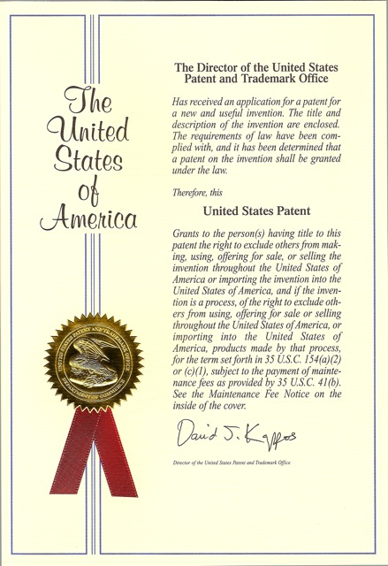

Suggested Caption:
New Way Air Bearings has been assigned United States Patent No. 7,908,885-B2,
covering a Porous Media Air Bearing and Glass-Flattening Device for Non-Contact Glass-Handling Applications.

Image B
A Comparison of Methodologies
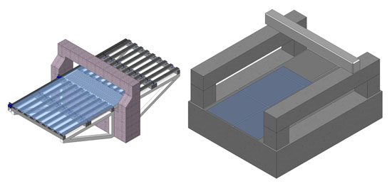
Suggested Caption:
Floating the glass on air conveyors vs. moving gantry architecture. The glass in these two examples is exactly the same size.

Image C
Structural Loop Comparison
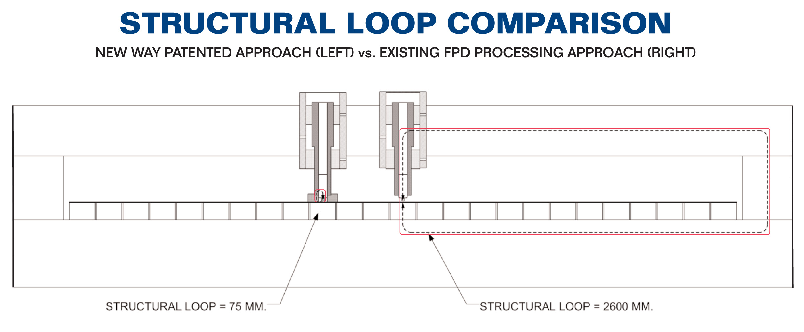
Suggested Caption:
New Way Air Bearings’ new patented concept provides a structural loop reduction of several magnitudes for Flat Panel Display (FPD) glass-handling and processing, all without contact.

Image D
New Way Transition Zone Air Bar – Front View (Single Unit)
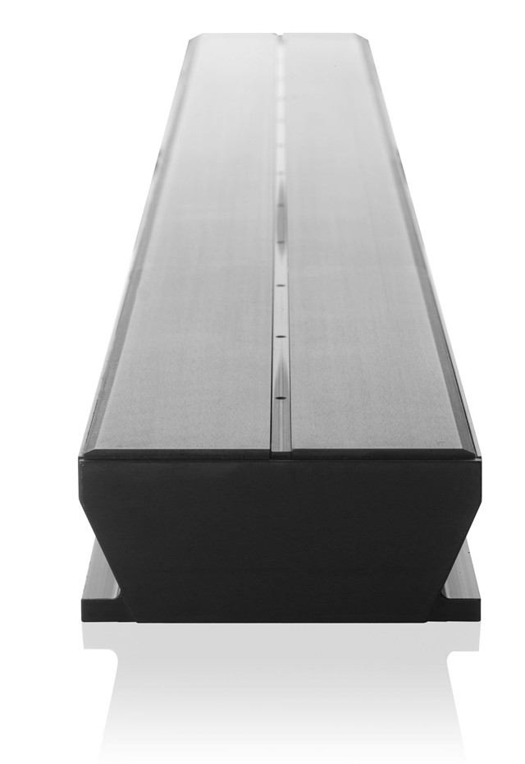

Suggested Caption:
The Transition Zone Air Bar (1250mm x 100mm component shown) is
a New Way Air Bearing product to which this new patent can be applied.

Image E
New Way Transition Zone Air Bar – Full Length (Pair)

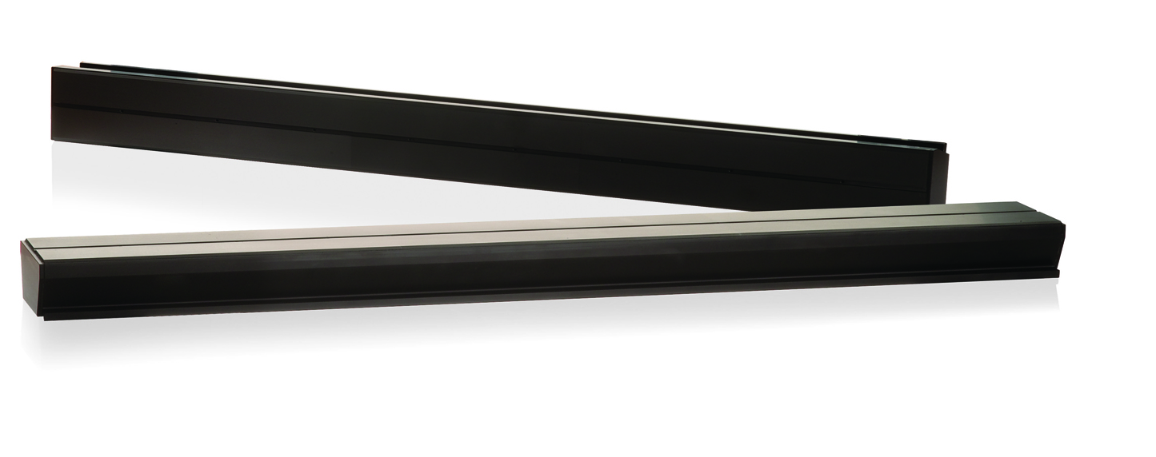

Suggested Caption:
The Transition Zone Air Bar (750mm x 100mm component shown) is a New Way Air Bearing product to which this new patent can be applied.

Image F
Drew Devitt – Informal Image
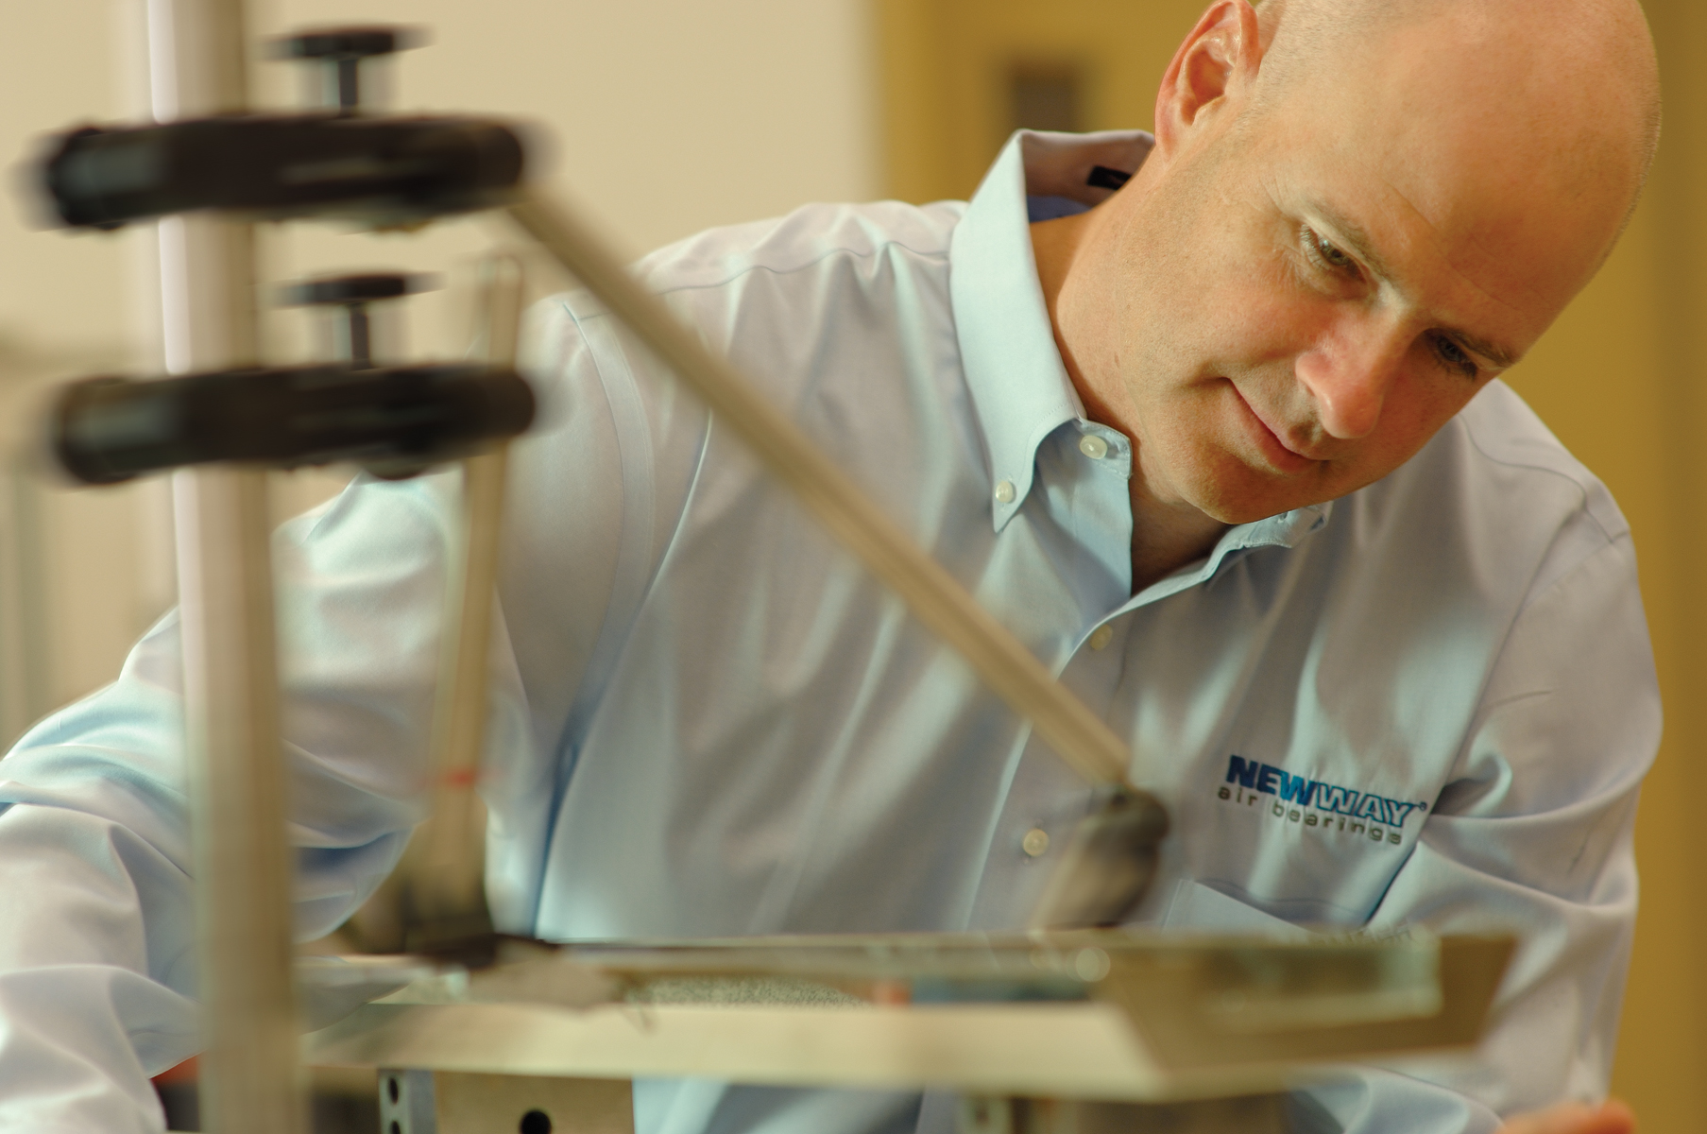

Suggested Caption:
New Way Air Bearings founder, chairman and chief technology officer Drew Devitt publishes the bi-weekly blog Drew’s Views.

Image G
Drew Devitt – Formal Image


Suggested Caption:
New Way Air Bearings founder, chairman and chief technology officer Drew Devitt will publish the bi-weekly blog Drew’s Views.

Image H
New Way Porous Media Visual
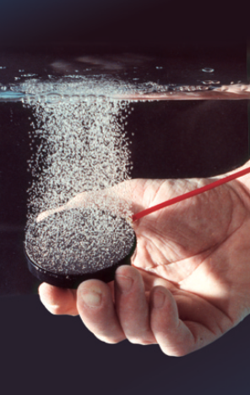

Suggested Caption:
New Way Porous Media Technology distributes air pressure uniformly across the entire bearing surface through millions of sub-micron sized holes.

Logo 1
New Way Air Bearings



