
FULL RELEASE

Contact Information:
Michael Wright
Director of Marketing
New Way Air Bearings
50 McDonald Blvd., Aston, PA 19014 USA
Phone 610.364.3453 Email mwright@newwayairbearings.com

FOR IMMEDIATE RELEASE
New Way Announces Assignment of Patent for Positioning and Control of FPD Glass

Aston, Pennsylvania, USA – Tuesday, November 13, 2012 – New Way® Air Bearings, the world's largest independent manufacturer of porous media air bearing products, announced that is has acquired ownership of US patent #6781684, titled ‘Workpiece Levitation Using Alternating Positive and Negative Pressure Flows.’ This patent, which was originally filed by Donald Ekhoff on November 7, 2000, adds to New Way’s intellectual property in the field of handling and control of thin substrates, particularly in the area of optical inspection of flat panel displays (FPDs).
“Our current and future customers can now be even more confident about the advantages of utilizing our technology in their applications,” states Nick Hackett, President of New Way.
New Way is an innovator in the field of non-contact handling and control of thin substrates including FPD glass. The Ekhoff patent describes “a support structure that utilizes a combination of positive pressure openings and negative pressure openings to precisely position a workpiece, such as a sheet of float glass.” Originally filed on November 7, 2000, The Ekhoff patent predates similar patents assigned to CoreFlow, Israel, a company that often competes with New Way in the FPD glass manufacturing marketplace.
--more—

As Drew Devitt, New Way’s Founder and Chief Technology Officer explains, “This patent complements our innovation in the field, and further solidifies our right to freely practice the art of FPD glass control using air and vacuum.”
Inquiries regarding New Way’s full range of FPD glass floating products and related technology should be directed to Tim Claffey, VP Sales, tclaffey@newwayairbearings.com.
About New Way Air Bearings®
New Way Air Bearings, Inc. is the world’s leading independent manufacturer of modular air bearing products and the recognized provider of porous media air bearing solutions. The company manufactures a standard line of modular, off-the-shelf components including: Flotation, transition and precision zone air bars; flat round and rectangular air bearings; vacuum preloaded air bearings; radial air bearings; air bushings; and air slides. The company achieved ISO 9001:2000 Certification for its quality management system in November, 2008; and achieved ISO 9001:2008 Certification in January, 2010.
New Way was included on Inc. Magazine's list of the 5,000 fastest-growing, private companies in America for 2007, 2008, and 2009. In November of 2007, The Greater Philadelphia Chamber of Commerce named New Way recipient of its Technological Excellence of the Year Award for 2008. In both 2008 and 2009, New Way was named a Deloitte Fast 50 Technology company for the Philadelphia, PA, USA Region.
Founded in 1994, New Way is located in Aston, Pennsylvania, USA, just fifteen minutes from Philadelphia International Airport. Visit New Way Air Bearings online at www.newwayairbearings.com. This web site includes specifications for the company’s full product range, design and installation guides, mounting hardware, air specifications, technical support, and a full range of accessories.
--more—

You can also find New Way on YouTube, Facebook and Twitter. If you’d prefer even more direct contact, you can reach us at info@newwayairbearings.com, or follow the company’s official blog: Drew’s Views.
###

High-Resolution Photography
High-resolution photography is available for use by the press at http://www.newwayairbearings.com/Photography-Products or by contacting Michael Wright directly using the information below.

Michael Wright
Director of Marketing
New Way Air Bearings
50 McDonald Blvd.
Aston, PA 19014 USA

Tel 610.364.3453
Fax 610.494.0911
Email mwright@NewWayAirBearings.com
Web www.NewWayAirBearings.com

Logo 1
New Way Air Bearings



Image A
Drew Devitt – Informal Image
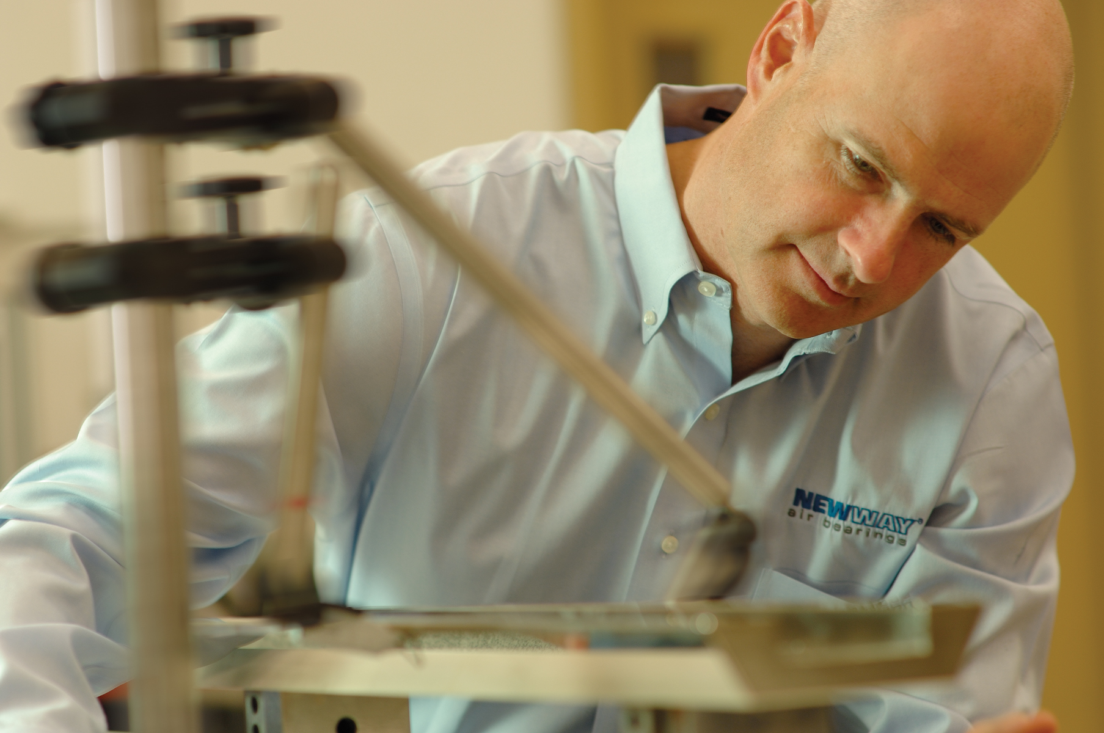

Suggested Caption:
New Way Air Bearings founder, chairman and chief technology officer Drew Devitt publishes the bi-weekly blog Drew’s Views.

Image B
Drew Devitt – Formal Image


Suggested Caption:
New Way Air Bearings founder, chairman and chief technology officer Drew Devitt publishes the bi-weekly blog Drew’s Views.

Image C
New Way Porous Media Visual
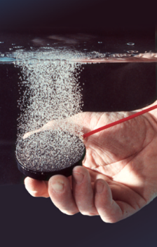

Suggested Caption:
New Way Porous Media Technology distributes air pressure uniformly across the entire bearing surface through millions of sub-micron sized holes.

